Incident Investigation Report

Module 3:Operation Overcast -Phase ll

Role: Lead Cloud Forensic Engineer

Analyst: Christiana Boi

Date: 28-04-2026

Executive Summary
A sophisticated threat actor used a stolen access key to gain access into organization’s data and compromise our AWS environment; using obfuscation, the attacker blended malicious activity within normal cloud operations; stealing credentials, exfiltrating sensitive financial documents, planting a hidden backdoor and also attempted to erase their tracks.

Tools Used:
- Powershell: Used to parse and analyze the AWS CloudTrail JSON log file, filter events, group IP addresses and extract key forensic artifacts.

- CyberChef: Used to decode Base64 encoded strings found within the log.

- VS Code: Used as the primary interface for viewing and navigating the CloudTrail log file.

1—— Credential Discovery
After thorough analysis, using the command; Get-Content "obehi christie - cloudtrail_log_dump.json" | ConvertFrom-Json | Group-Object {$_.userIdentity.accessKeyId} | Sort-Object Count -Descending , the stolen Access Key ID used for the bulk of the attack was AKIA_DEV_PROD_9982

This key was used to perform reconnaissance, escalate privileges, exfiltrate sensitive data and create a backdoor user account.

All malicious actions were traced- back to this single compromised credential.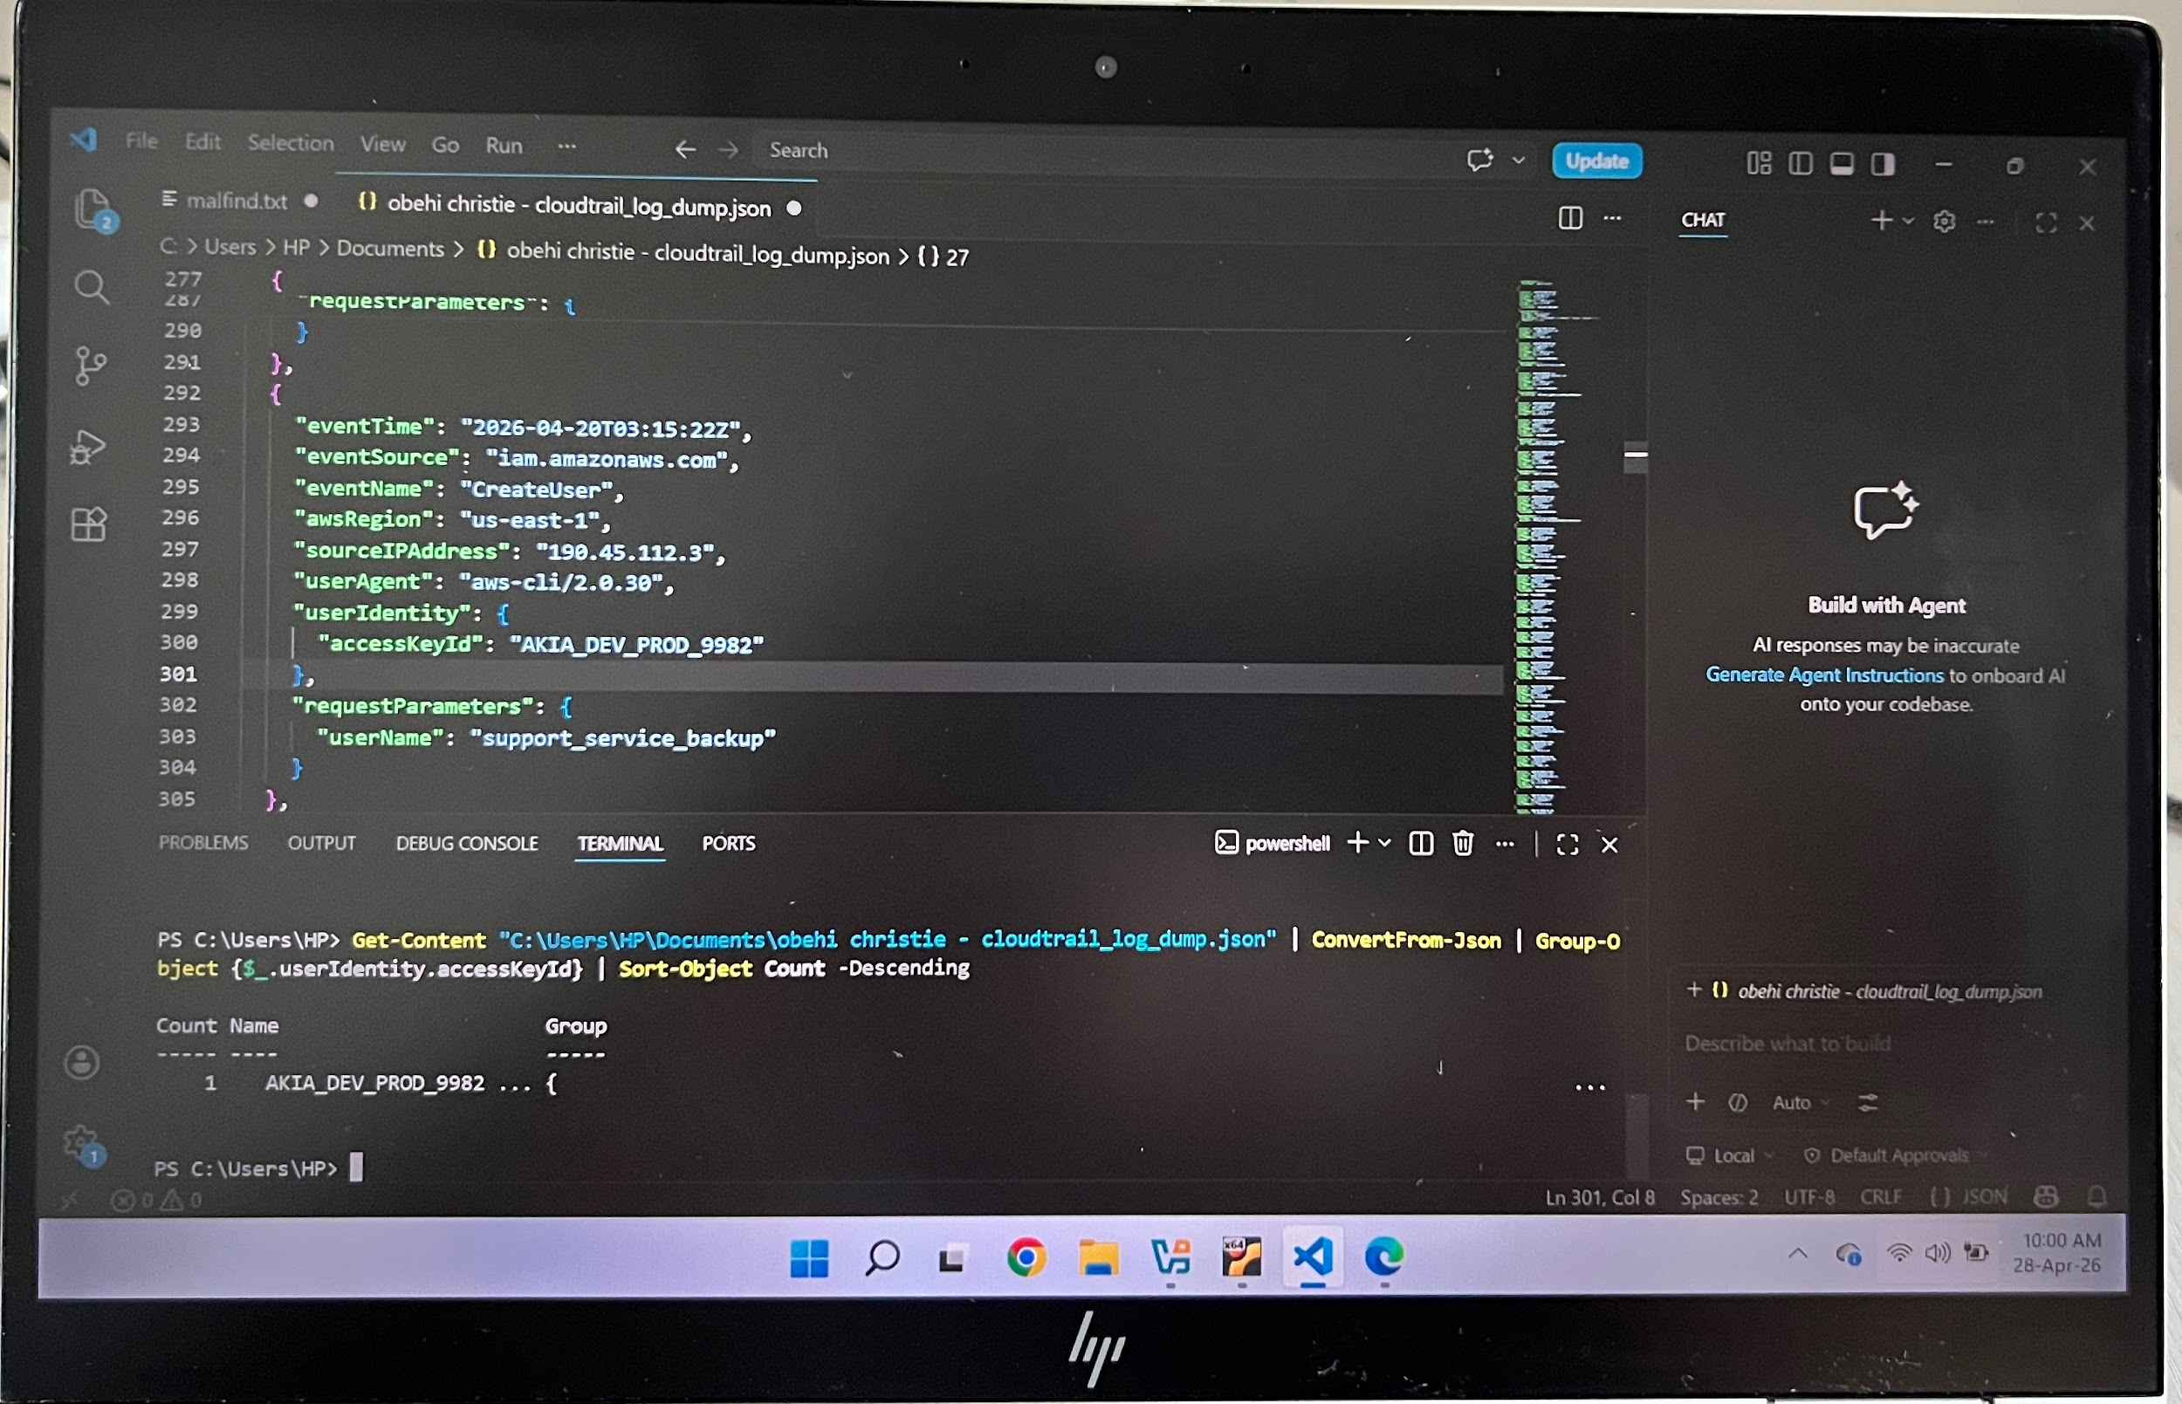

2—— IP Forensic Tracking
—-The attacker’s initial IP was 190.45.112.3

This IP was first seen at 2026-04-20T01:15:33Z performing a GetCallerIdentity call; a classic first move by an attacker to confirm whose credentials they have stolen.

I was able to identify the attacker’s IP addresses by grouping all the events in the CloudTrail logs and by count using Powershell which revealed a list of all IPs that interacted with the AWS environment.

After analysis, internal and legitimate AWS IPs were eliminated, leaving two suspicious external IPs.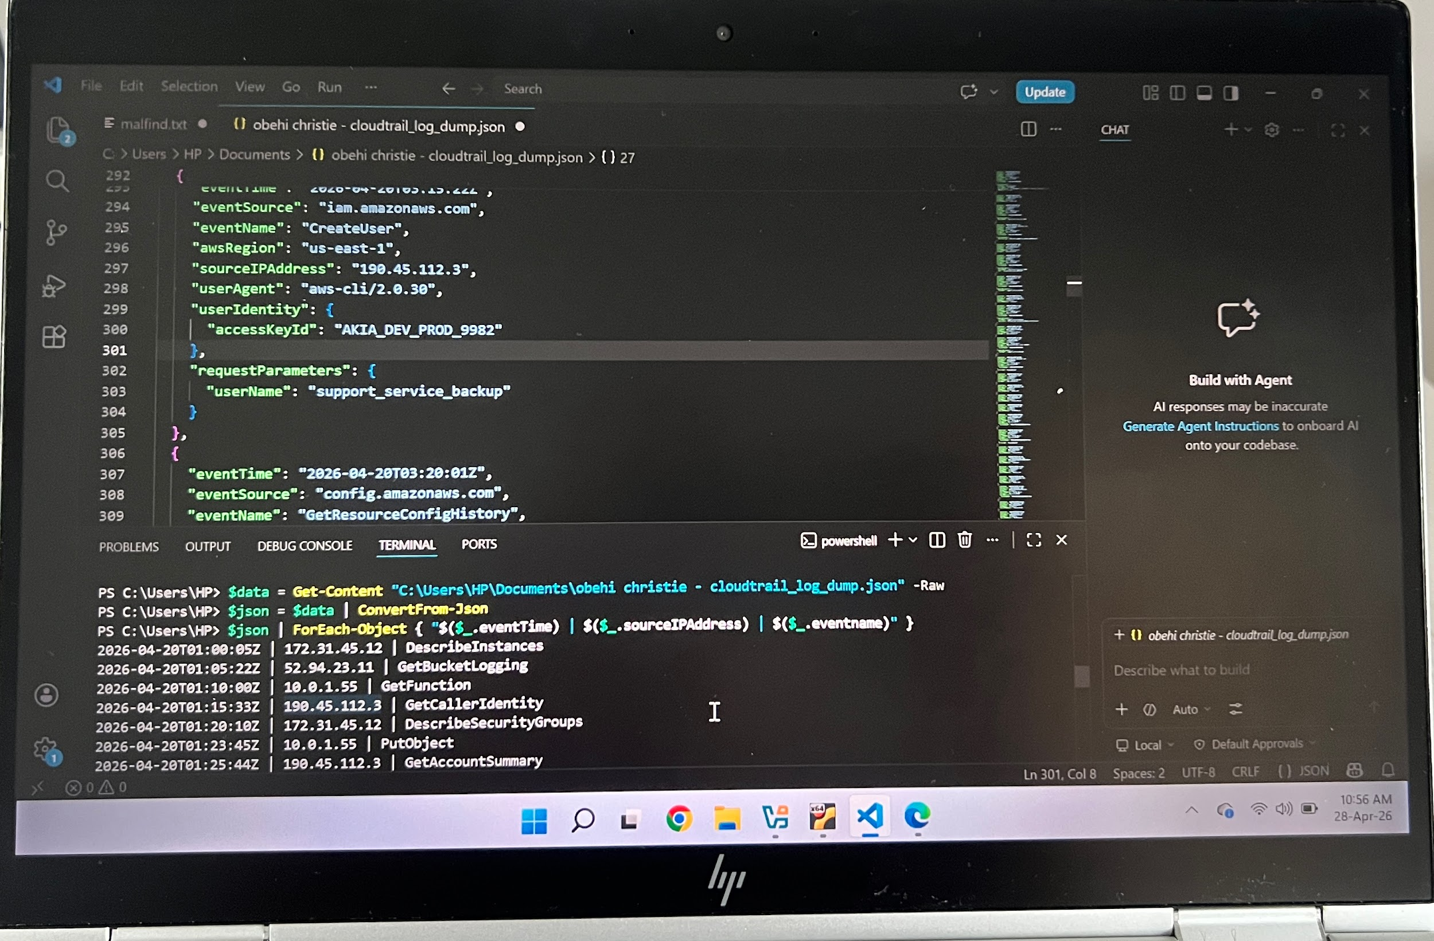

——Second IP
The second IP used for persistence is 45.33.10.11

The IP appeared at 2026-04-20T03:35:45Z performing CreateAccessKey.

This IP took over operations creating a backdoor key, attempting to stop logging and ultimately disabling the original stolen key.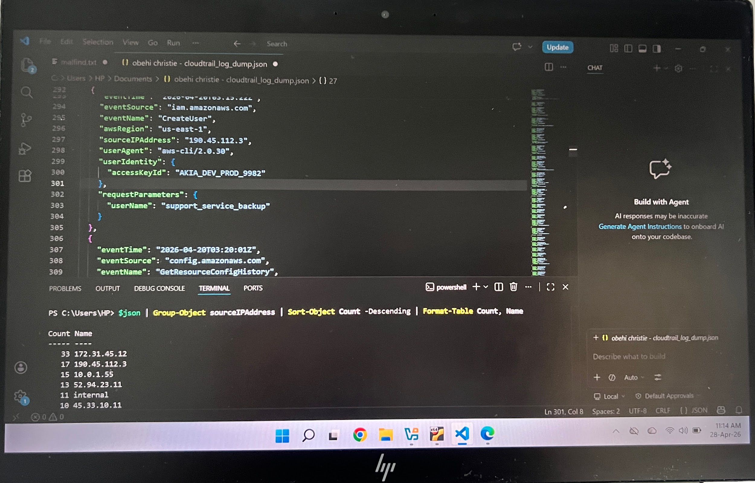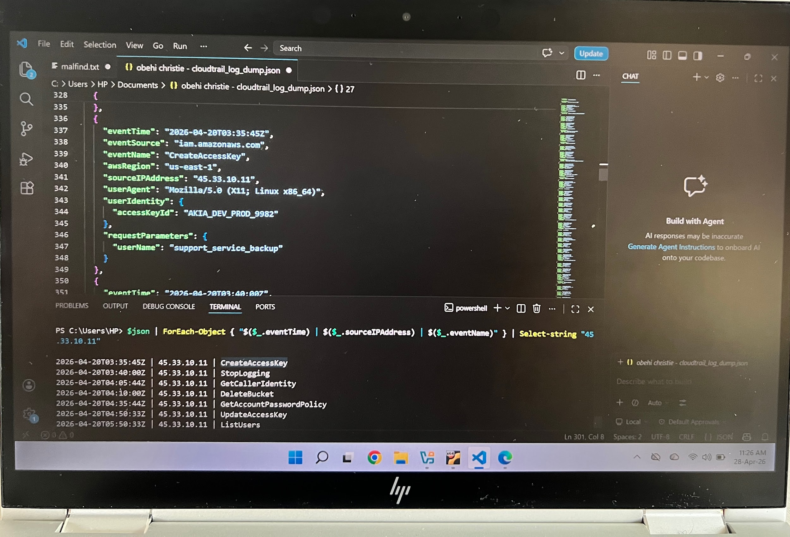

Commands used:
$json | Group-Object sourceIPAddress | Sort-Object Count -Descending | Format-Table Count, Name

$json | ForEach-Object { "$($_.eventTime) | $($_.sourceIPAddress) | $($_.eventName)" } | Select-String "45.33.10.11"

3—— Obfuscated Data Analysis (Signal vs Noise)

The two base 64 encoded strings are;

Encoded: c2V0dGluZzogYmFja3VwX2VuYWJsZWQ9dHJ1ZQ==

Decoded: setting: backup_enabled=true

Encoded: ZGJfcGFzczogUEBzc3cwcmRfQ2xvdWRfMjAyNiE=

Decoded: db_pass: P@ssw0rd_Cloud_2026!

- The legitimate string is c2V0dGluZzogYmFja3VwX2VuYWJsZWQ9dHJ1ZQ==

- while the malicious string is ZGJfcGFzczogUEBzc3cwcmRfQ2xvdWRfMjAyNiE= 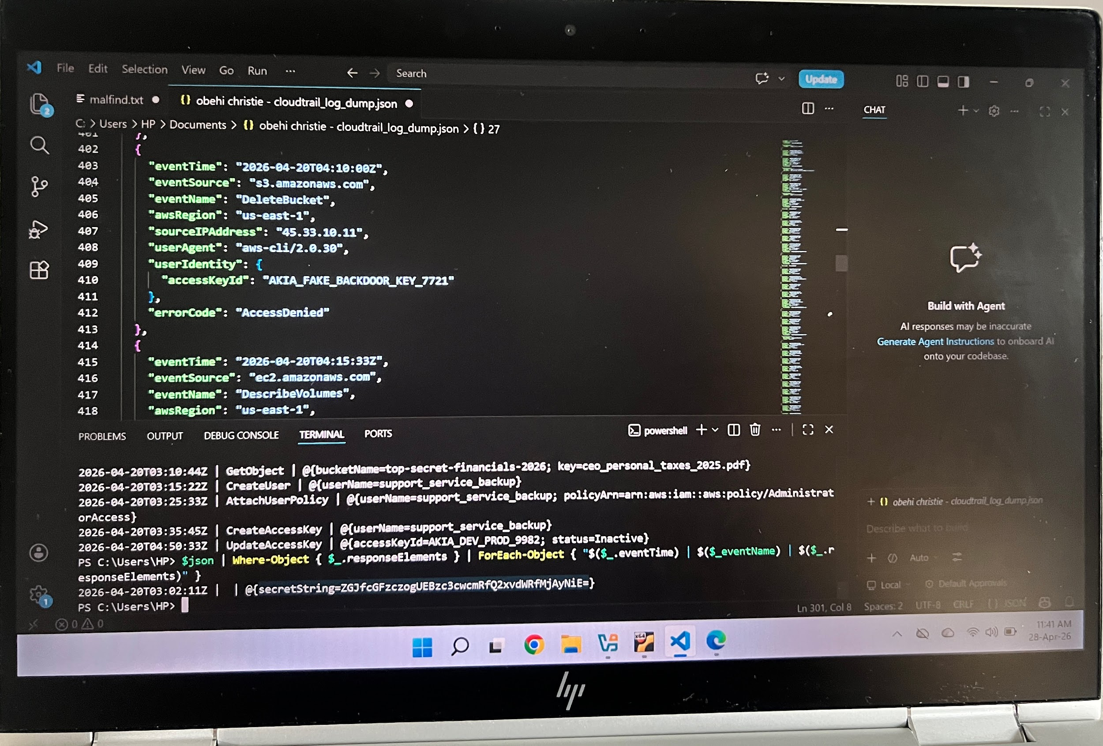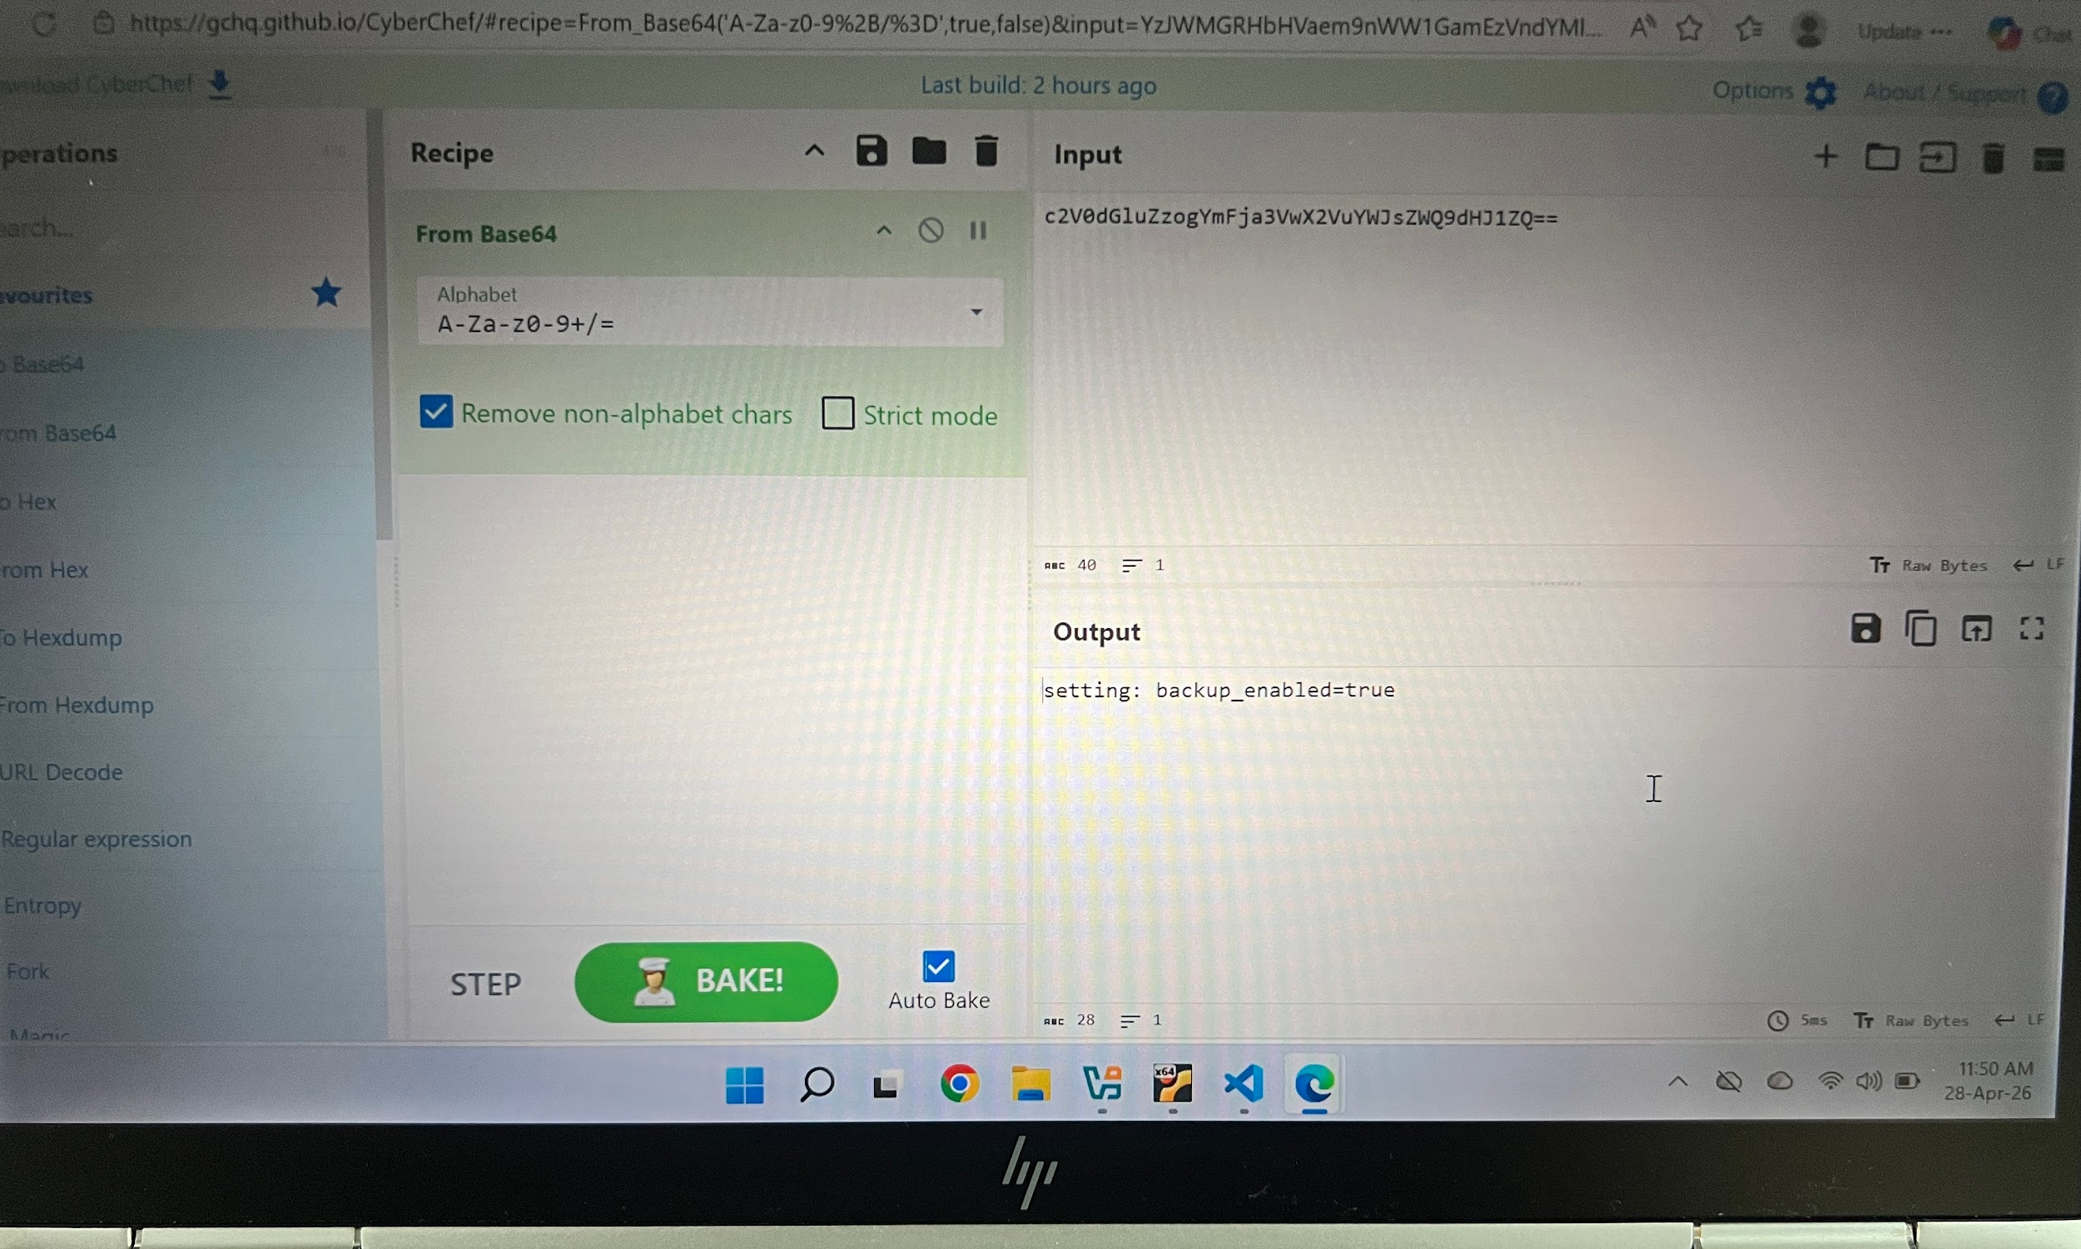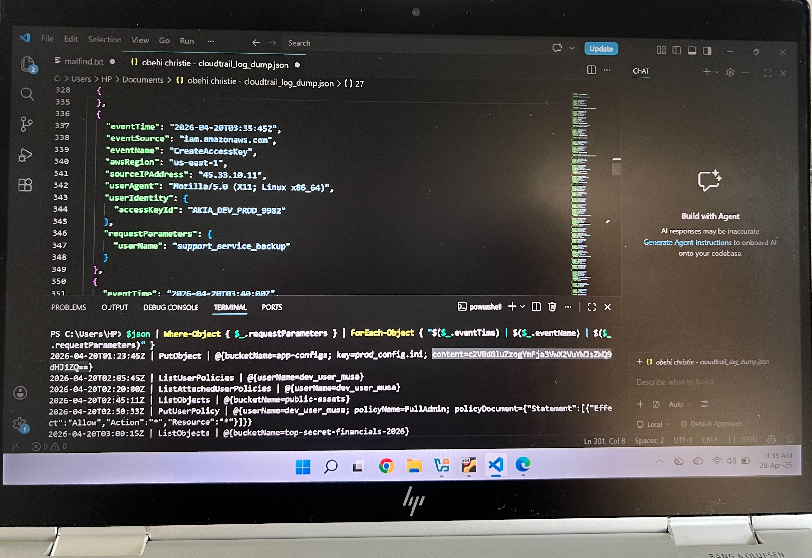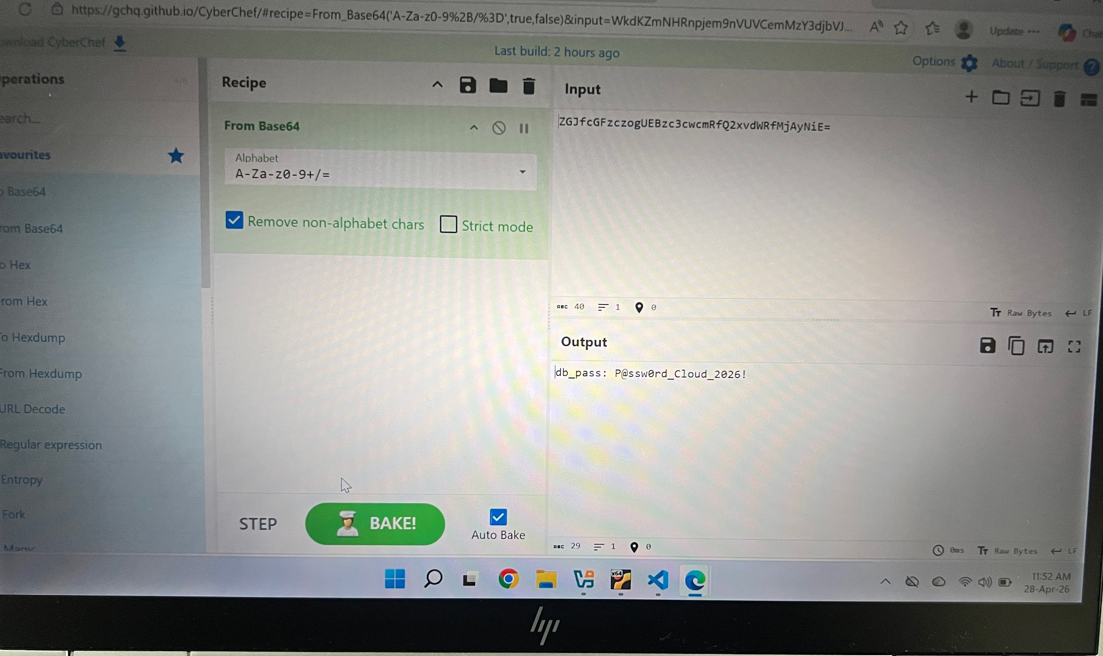

—-From the decoded strings, I was able to deduce that;
- String 1 shows a routine system configuration confirming that backup was enabled on the system which is a normal developer activity hence poses no threat.

- String 2 reveals a live database password P@ssw0rd_Cloud_2026! was stored in AWS Secrets Manager. The attacker deliberately accessed and extracted this password which means that they now have direct access to the organization’s database.

This is a critical finding and the database must be considered compromised and the password must be changed immediately.

4— Administrative Escalation
The specific timestamps as to when the attacker granted themselves full administrative privileges was
2026-04-20T02:50:33Z and 2026-04-20T03:25:33Z .
While the API call is; PutUserPolicy and AttachUserPolicy.

This was deduced after all policy related events were extracted from the logs using PowerShell.

The attacker granted full administrative privileges to existing user dev_user_musa by attaching a policy with ‘Action and Resource’ which means; allow unrestricted access to everything in the AWS environment, then the attacker went further to attach the AdministratorAccess policy to the newly created backdoor giving it full admin privileges.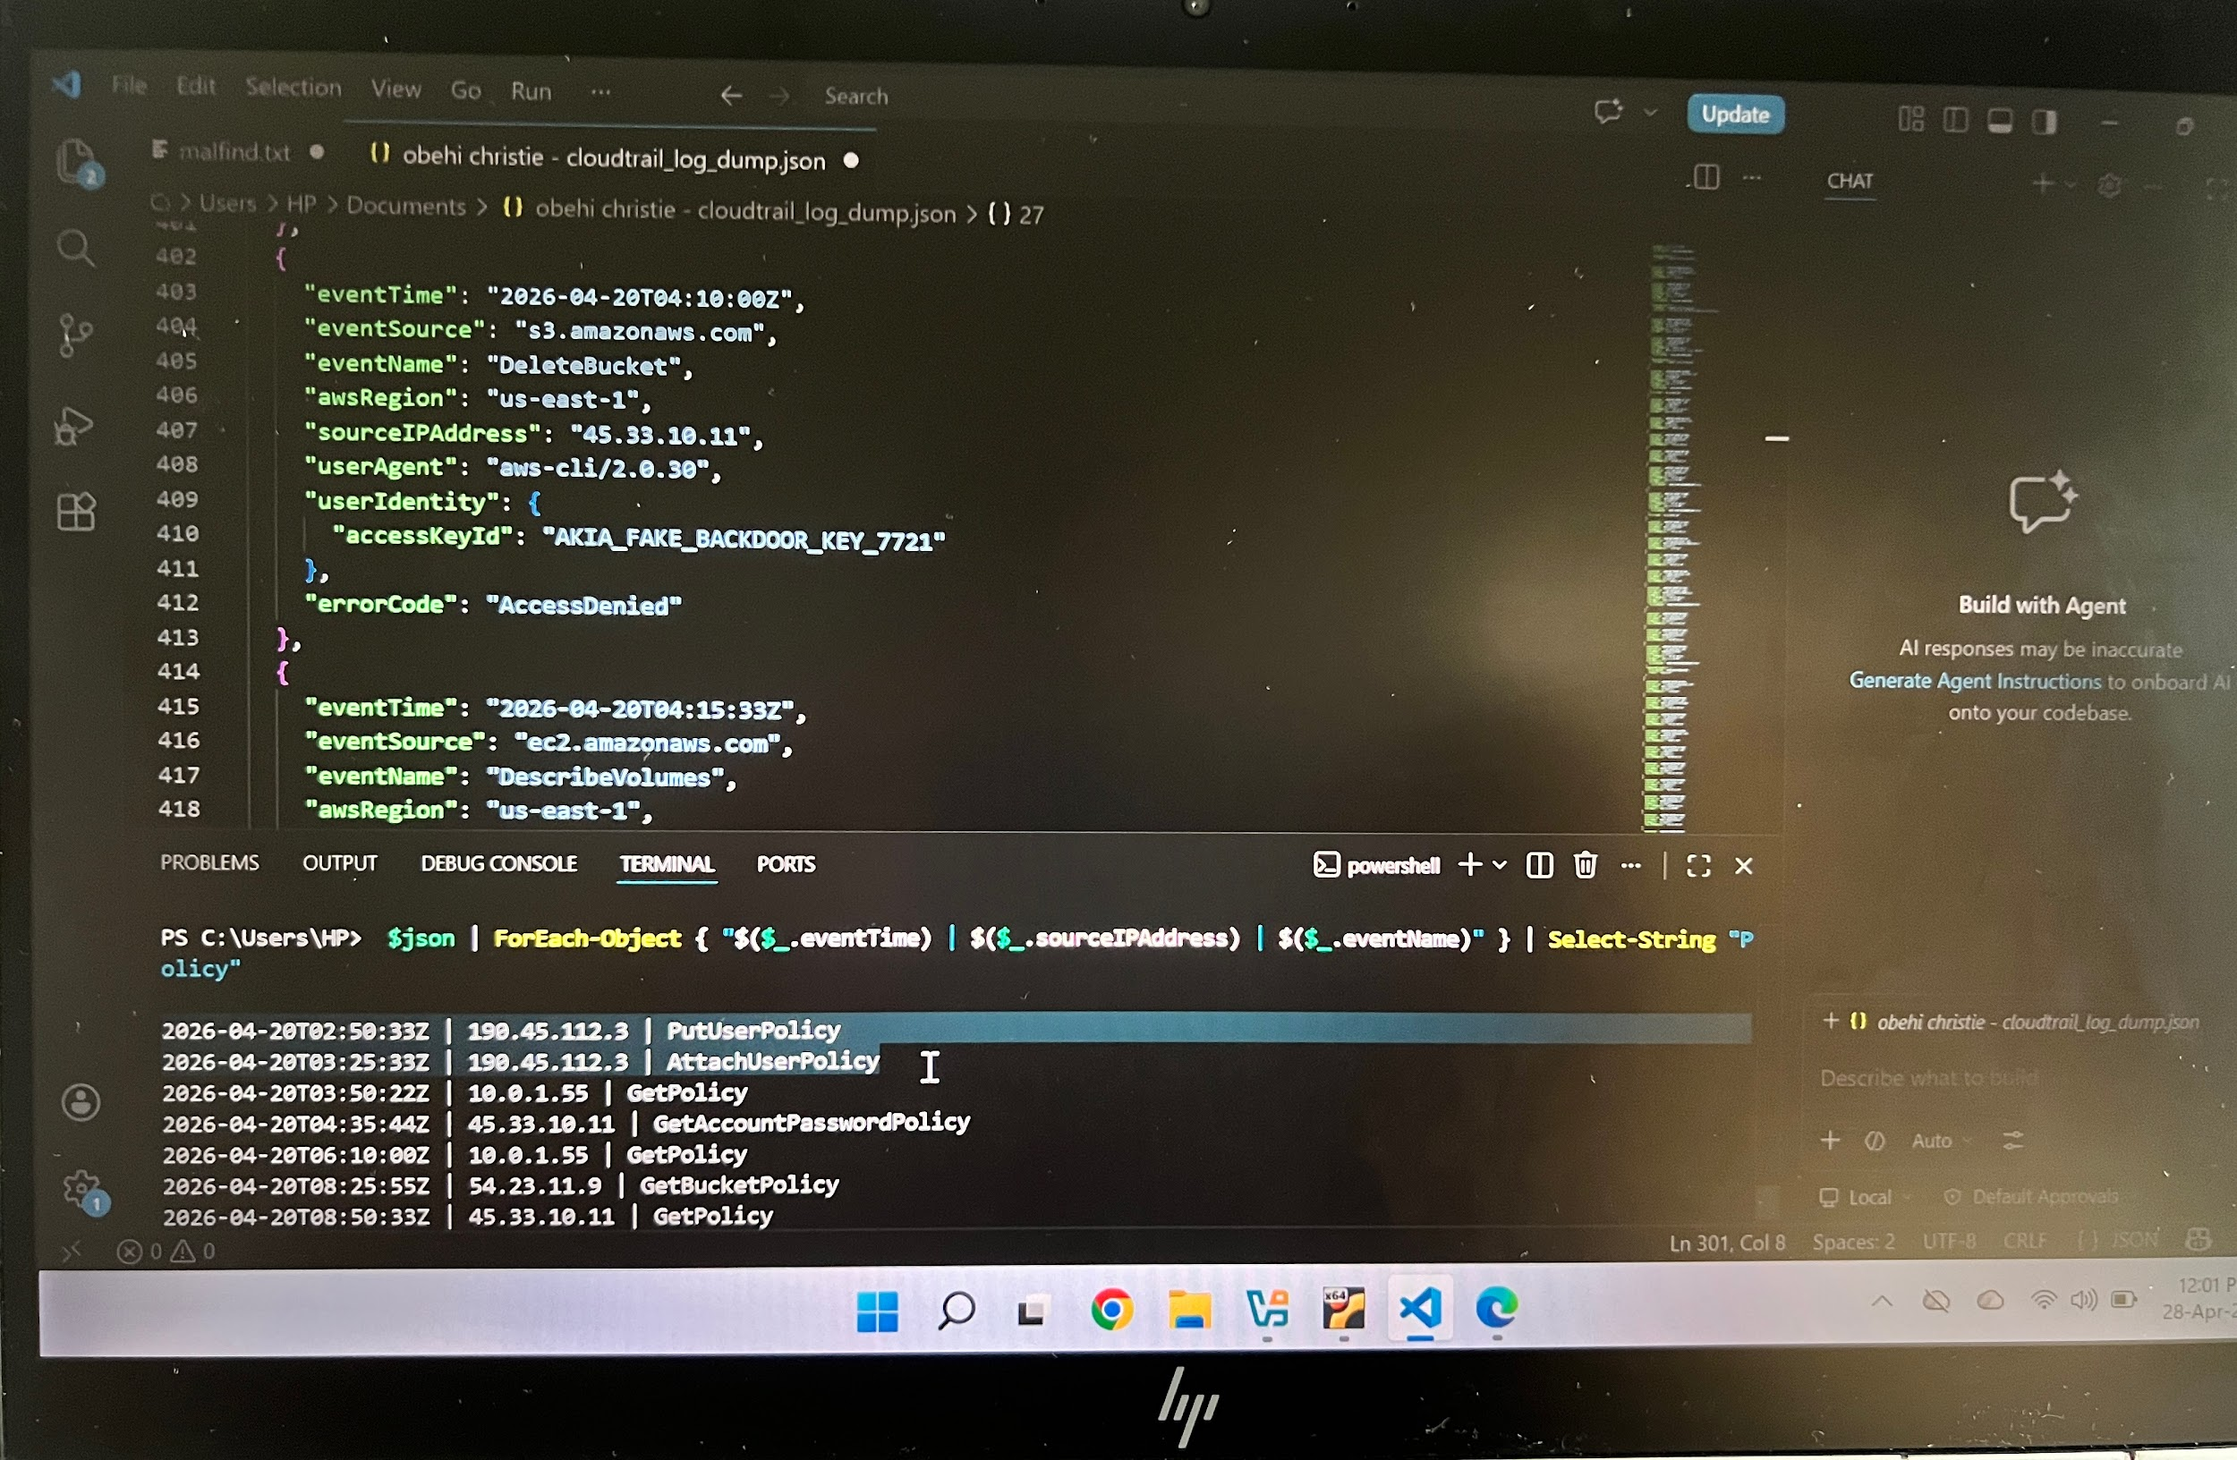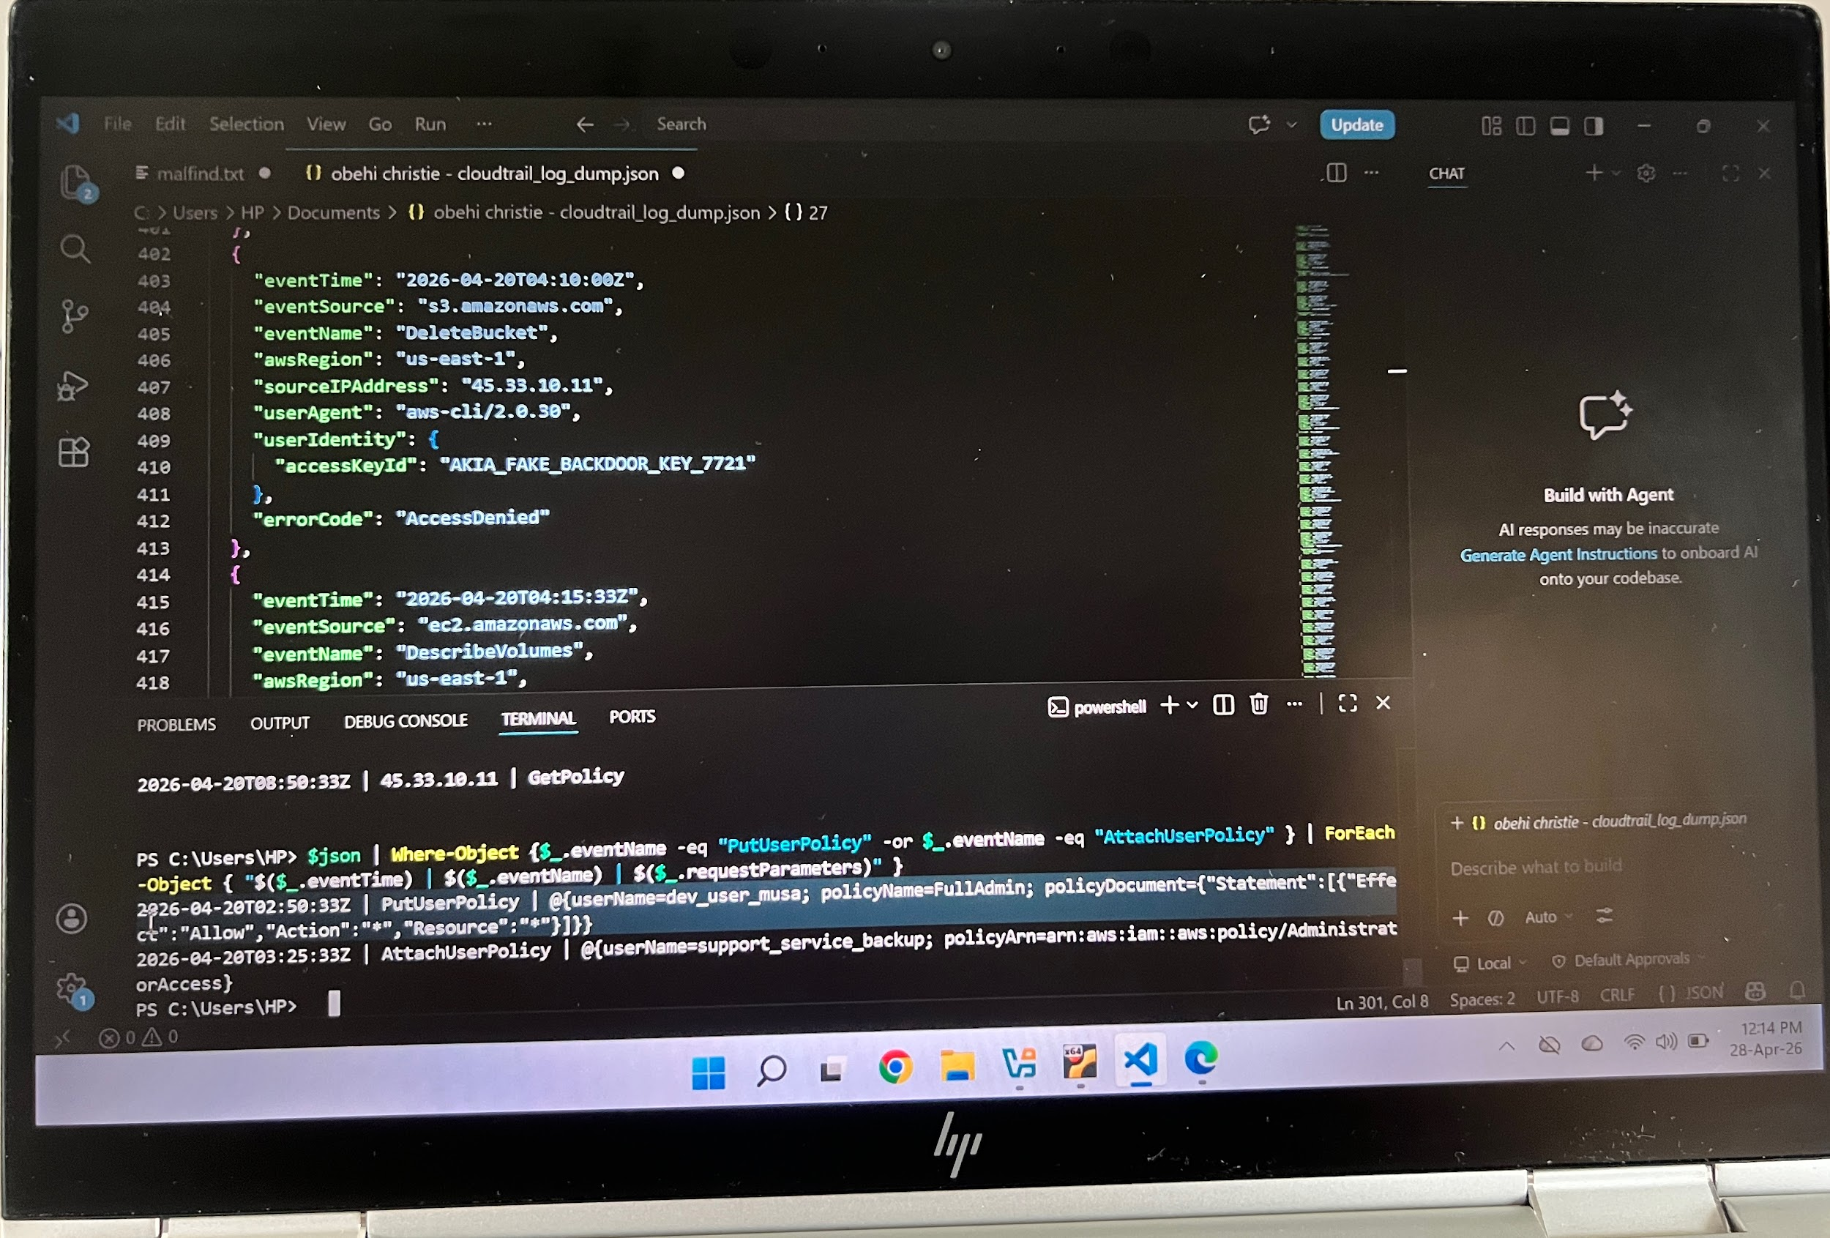

Commands used:
$json | ForEach-Object { "$($_.eventTime) | $($_.sourceIPAddress) | $($_.eventName)" } | Select-String "Policy"
$json | Where-Object { $_.eventName -eq "PutUserPolicy" -or $\_.eventName -eq "AttachUserPolicy" } | ForEach-Object { "$($_.eventTime) | $($_.eventName) | $($_.requestParameters)" }

5———- The Theft
At 2026-04-20T03:10:44Z, the attacker downloaded a highly sensitive file from S3 using the stolen key AKIA_DEV_PROD_9982 from IP 190.45.112.3

Bucket Name: top-secret-financials-2026

File Name: ceo_personal_taxes_2025.pdf

This was concluded after thorough investigation and after all GetObject events were extracted from the logs using PowerShell.

Commands used:
$json | ForEach-Object { "$($_.eventTime) | $($_.sourceIPAddress) | $($_.eventName)" } | Select-String "GetObject"
$json | Where-Object { $\_.eventName -eq "GetObject" } | ForEach-Object { "$($_.eventTime) | $($_.requestParameters)" }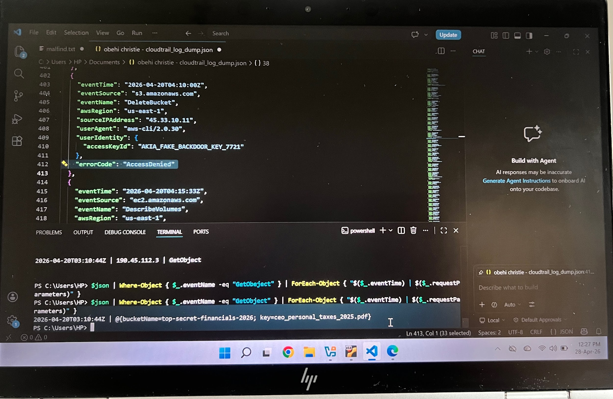

6—— Persistence & Evasion
The attacker created a new IAM user named support_service_backup; a name deliberately chosen to appear as a legitimate system account and blend in with normal activity.

This was concluded after all CreateUser and UpdateAccessKey events were extracted from the logs using PowerShell.

Commands used:
$json | ForEach-Object { "$($_.eventTime) | $($_.sourceIPAddress) | $($_.eventName)" } | Select-String "CreateUser"
$json | Where-Object { $\_.eventName -eq "CreateUser" } | ForEach-Object { "$($_.eventTime) | $($_.requestParameters)" }
$json | Where-Object { $\_.eventName -eq "UpdateAccessKey" } | ForEach-Object { "$($_.eventTime) | $($_.requestParameters)" }

- At 2026-04-20T04:50:33Z, the attacker’s final action was to disable the original stolen key AKIA_DEV_PROD_9982 by setting its status to Inactive.

- By disabling the original key, the attacker effectively locked out the legitimate owner, ensured their backdoor key AKIA_FAKE_BACKDOOR_KEY_7721 was the only active key and covered their tracks making it harder to trace the initial compromise.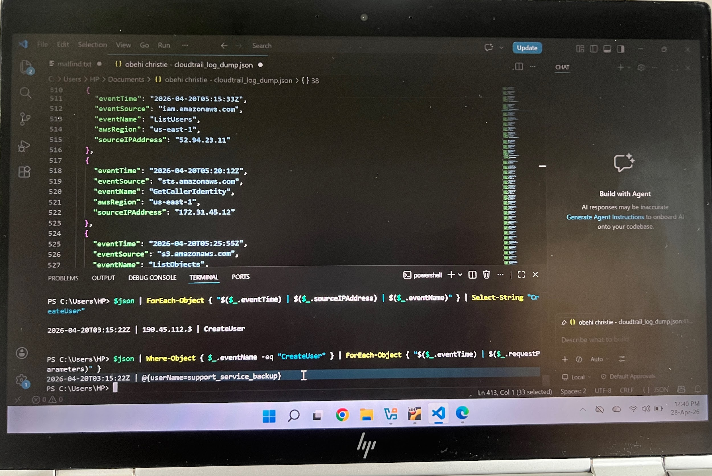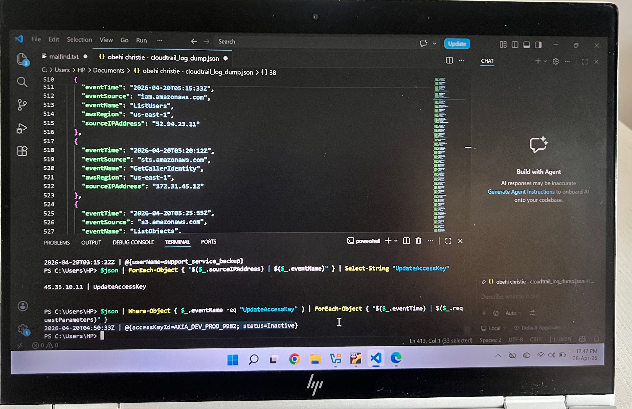

Conclusion
This investigation successfully deconstructed a sophisticated and highly obfuscated AWS cloud compromise after thorough analysis of CloudTrail logs.

I will recommend that the database password p@ssw0rd_Cloud_2026 be changed immediately.

The two IP addresses of the attacker be blocked at network level, backdoor user support_ service_backup be deleted and all permissions revoked instantly.

CloudTrail alert should be enabled for suspicious API calls, user dev_user_musa should be investigated as full admin privileges was granted to the account and lastly, disable and rotate all active access keys immediately.

